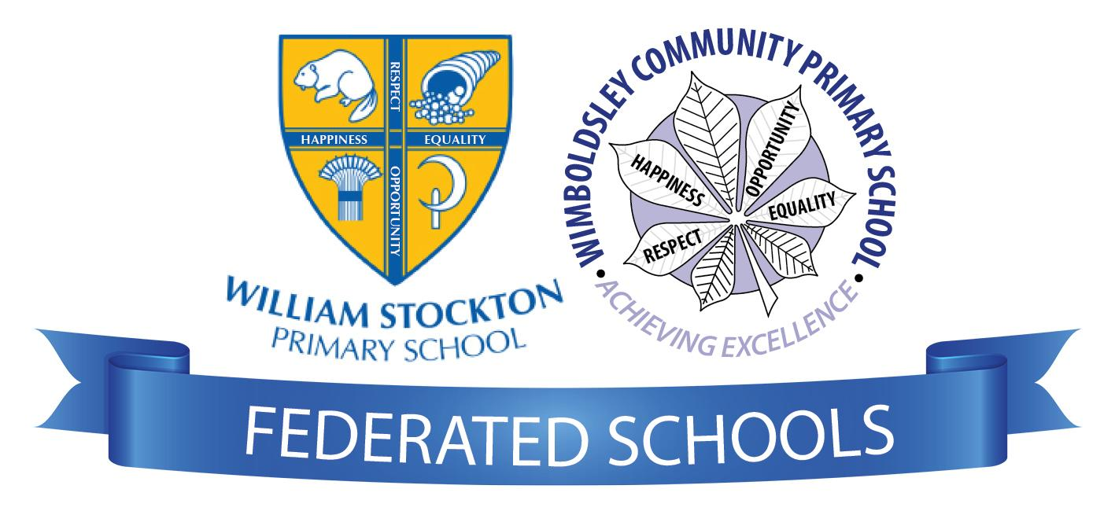
Geography Curriculum Statement

‘Achieve Excellence’
Geography

Intent
At William Stockton, we believe our curriculum will:
- Provoke and provide answers to questions about the natural and human aspects of the world.
- Instil a love and wonder of geography through the classroom environment and the wonder of the curriculum
- Encourage the children’s cultural capital - giving the pupils the vital background knowledge to be informed and thoughtful members of our community
- Develop the children’s understanding and knowledge of the world as well as their place in it.
- Develop knowledge and skills that are transferable to other curriculum areas
- Form strong and meaningful schemas by using retrieval strategies to make links to what the children already know, encouraging the new learning to be stored in the long term memory.
- Inspire children’s curiosity and fascination about the world around them
- Promote the children’s interest and understanding of diverse places, people, resources and natural and human environments.
- Use outdoor resources and opportunities as well as their locality to enhance their learning

Implementation
Based upon the National Curriculum and the individual needs of our children, we have created a Geography Long Term Plan, which sets out the objectives taught in each year group/key stage.
We alternate our Geography and History topic blocks ensuring that our children receive a well rounded teaching of the humanities subjects throughout the year and develop key knowledge and skills. At times, we take the opportunity to create links between the two subjects to help solidify the learning taking place

Within Geography sessions, Teachers use questioning, and provide opportunities for discussion and investigation to support the development of vocabulary, which is explicitly taught and modelled by teachers in every lesson. Key geographical knowledge and language (such as, the name and location of continents, countries, capital cities and oceans) is revisited frequently, to make learning memorable, relevant and easy to retrieve. We make interconnected links between subjects that we are teaching to ensure that these links strengthen the schema that the children are developing.

At the beginning of each topic children are asked to convey what they know already as well as what they would like to find out and how they can find out the new information (KWHL/Schema) - this helps the children to concentrate their minds on the skills that they will need to develop to learn successfully.

Consideration is given to how greater depth will be taught, learnt and demonstrated within each lesson, as well as how learners will be supported in line with the school’s commitment to inclusion,
Cross curricular outcomes are promoted by making interconnected links with other areas of the curriculum. Retrieval of previously learned content is frequent and regular which increases both storage and retrieval strength meaning the children know more and remember more.
Mastery of objective are managed by repetition and ensuring that children are provided with the opportunities to learn the skills and knowledge in a number of ways to sustain mastery.

The local area is fully utilised to achieve the desired outcomes, with opportunities for learning outside the classroom embedded into daily practice. Both schools within the Federation are positioned in contrasting areas, therefore strong links between the schools help to develop and widen the children’s knowledge and skills of a contrasting locality.

Impact
Outcomes can be seen within Individual Geography books but also through other curriculum areas such as Literacy and Science. Outcomes in books will demonstrate children’s knowledge and skills. Skilled questioning in sessions will allow teachers to assess and probe children’s understanding. Children record what they have learned comparative to their starting points at the end of each topic.

A joint approach across the federation allows children to develop an understanding of contrasting places across Cheshire. As children progress throughout the school, they develop a deep knowledge, understanding an appreciation of their local area and its place within the wider geographical context. Regular school trips and residential opportunities provide further relevant and contextual learning.

We use our school monitoring system, ‘Precision Teach’ to ensure that when looking at deliberate practice, we determine whether they are appropriate and related to our goals and likely to produce results. We use this also to make comparative judgements by comparing a pupils work over time; by using lesson observations and monitoring to see if the pedagogical style matches our expectations.

After following the curriculum the Geography Curriculum, the children will leave:
- Have a growing knowledge of the world and their place in it.
- Have a wider vocabulary of geographical terms.
- Aspire to discover more about the world, through reading, travel or the media.
- Know that they can use their voice to express themselves and their opinions. Develop their geographical skills, such as, evaluation, creativity, problem solving and enquiry.

