
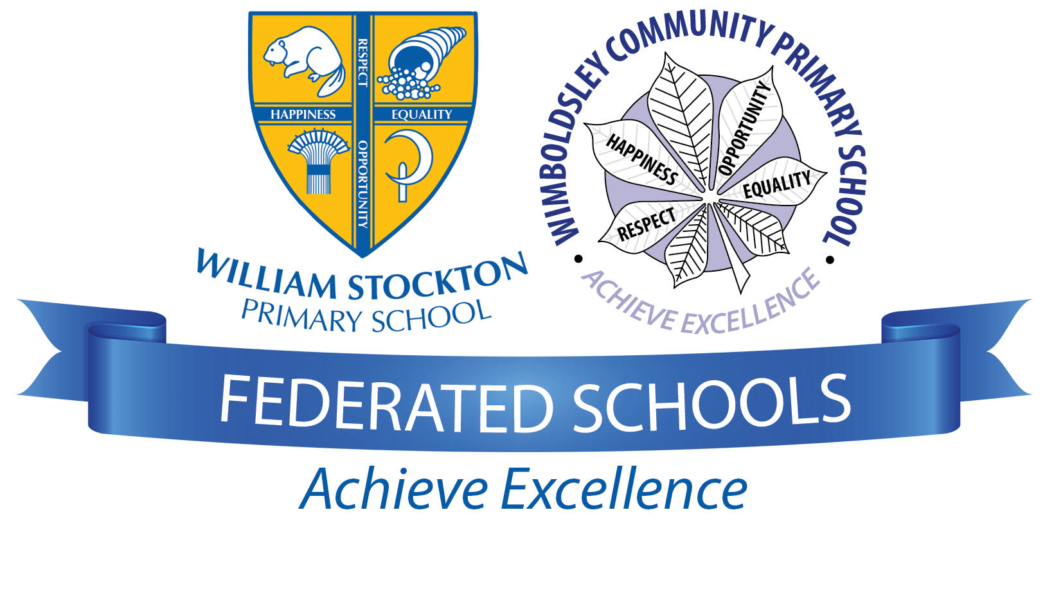
Where to go for more information
Contact the school
If you have any questions or concerns about the Prevent strategy and what it means for your child, please do not hesitate to contact the school.

See our policies
You will find more details about radicalisation in our safeguarding policy, available on our website.
We also have information about spiritual, moral, social and cultural development and British values.

External sources
The following sources may also be useful for further information:
Prevent duty guidance: for England and Wales, HM Government
https://www.gov.uk/government/uploads/system/uploads/attachment_data/file/417943/Prevent_Duty_Guidance_England_Wales.pdf
Frequently asked questions, Prevent For Schools
http://www.preventforschools.org/?category_id=38
What is Prevent? Let’s Talk About It
http://www.ltai.info/what-is-prevent/

The Prevent strategy
KEY TERMS
Extremism – vocal or active opposition to fundamental British values such as democracy, the rule of law and tolerance of different faiths and beliefs
Ideology – a set of beliefs
Terrorism – a violent action against people or property, designed to create fear and advance a political, religious or ideological cause
Radicalisation – the process by which a person comes to support extremism and terrorism

Frequently Asked Questions
How does Prevent relate to British values?
Schools have been required to promote British values since 2014, and this will continue to be part of our response to the Prevent strategy.
British values include:
- Democracy
- The rule of law
- Individual liberty and mutual respect
- Tolerance of different faiths and beliefs
Isn’t my child too young to learn about extremism?
The Prevent strategy is not just about discussing extremism itself, which may not be appropriate for younger children. It is also about teaching children values such as tolerance and mutual respect.
The school will make sure any discussions are suitable for the age and maturity of the children involved.
Is extremism really a risk in our area?
Extremism can take many forms, including political, religious and misogynistic extremism. Some of these may be a bigger threat in our area than others.
We will give children the skills to protect them from any extremist views they may encounter, now or later in their lives.
What does this mean in practice?
Many of the things we already do in school to help children become positive, happy members of society also contribute to the Prevent strategy.
These include:
- Exploring other cultures and religions and promoting diversity
- Challenging prejudices and racist comments
- Developing critical thinking skills and a strong, positive self-identity
- Promoting the spiritual, moral, social and cultural development of pupils, as well as British values such as democracy
We will also protect children from the risk of radicalisation, for example by using filters on the internet to make sure they can’t access extremist and terrorist material, or by vetting visitors who come into school to work with pupils.
Different schools will carry out the Prevent duty in different ways, depending on the age of the children and the needs of the community.

What is the Prevent strategy?
Prevent is a government strategy designed to stop people becoming terrorists or supporting terrorist or extremist causes.
The Prevent strategy covers all types of terrorism and extremism, including the extreme right wing, violent Islamist groups and other causes.
How does the Prevent strategy apply to schools?
From July 2015 all schools (as well as other organisations) have a duty to safeguard children from radicalisation and extremism.
This means we have a responsibility to protect children from extremist and violent views the same way we protect them from drugs or gang violence.
Importantly, we can provide a safe place for pupils to discuss these issues so they better understand how to protect themselves.

KEY TERMS
Extremism – vocal or active opposition to fundamental British values such as democracy, the rule of law and tolerance of different faiths and beliefs
Ideology – a set of beliefs
Terrorism – a violent action against people or property, designed to create fear and advance a political, religious or ideological cause
Radicalisation – the process by which a person comes to support extremism and terrorism

KEY TERMS
Extremism – vocal or active opposition to fundamental British values such as democracy, the rule of law and tolerance of different faiths and beliefs
Ideology – a set of beliefs
Terrorism – a violent action against people or property, designed to create fear and advance a political, religious or ideological cause
Radicalisation – the process by which a person comes to support extremism and terrorism

KEY TERMS
Extremism – vocal or active opposition to fundamental British values such as democracy, the rule of law and tolerance of different faiths and beliefs
Ideology – a set of beliefs
Terrorism – a violent action against people or property, designed to create fear and advance a political, religious or ideological cause
Radicalisation – the process by which a person comes to support extremism and terrorism

KEY TERMS
Extremism – vocal or active opposition to fundamental British values such as democracy, the rule of law and tolerance of different faiths and beliefs
Ideology – a set of beliefs
Terrorism – a violent action against people or property, designed to create fear and advance a political, religious or ideological cause
Radicalisation – the process by which a person comes to support extremism and terrorism

